A000-D R Congo-Lega People- *Lukwakongo* Mask-wood, pigment and plant fiber, early 20th c

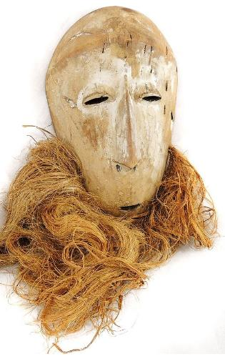

Fig. 1. D R Congo-Lega People- *Lukwakongo* Mask-wood, pigment and plant fiber, early 20th c

Case No.: 6

**Accession No.**

**Formal Label:**

**Display Description:**

This maskette is heart-shaped with a concave face and with white clay applied to the facial area. It has open slit eyes and an open mouth with a long, narrow, straight nose dividing the face. It is adorned with the important fiber beard *(luzelu)* attached to a set of holes in the area of the chin. A string in the back is used to attach the maskette to the body or it is held in the hand or hung on a fence or pole during the initiation ceremonies of the Bwami society: it is not worn on the face. The Bwami society masks are divided into five types according to material, size, and form: *lukwakongo, kayamba, idimu, muminia*, and *lukungu* (Biebuyck 1973,164). They outwardly serve as an important mark of rank, identifying the owners as members of specific Bwami levels. They inwardly serve as expressions of transcendent relationships between the living and the dead -- links that exist between those who have "inherited" the mask and their aged, ancestral predecessor, symbolized by the toothless mouth, the whitened and bearded face of the maskette. These transcendent relationships are enacted in ceremonies that embody communal moral values by contrasting good and evil actions through pro­found, dramatic rituals in which the masks act as persona for articulated societal values spoken by the Lukwakongo. These ritualized dramas must be learned only within the context of a system of secret initiations.

**LC Classification:**

**Date or Time Horizon:**

**Geographical Area:**

**Map:**

**GPS coordinates:**

**Cultural Affiliation:**

**Media:**

**Dimensions:**

**Weight:**

**Condition:**

**Provenance:**

**Discussion:**

**References:**

Ref.: Daniel P Biebuyck. *Lega culture; art, initiation, and moral philosophy among a Central African people*. Los Angeles: University of California Press, 1973.